(Approx. 1,175 words)

Website Technology
By Dick Maybach, Member, Brookdale Computer Users’ Group, NJ
November 2015 issue, BUG Bytes
www.bcug.com
n2nd (at) att.net

As you browse Websites on the Internet, the processes that produce the screens on your computer are much more complex and interesting than you probably think and require ongoing conversations between local and remote software. We can class Websites into two types, static and dynamic. The diagram below summarizes the static case.

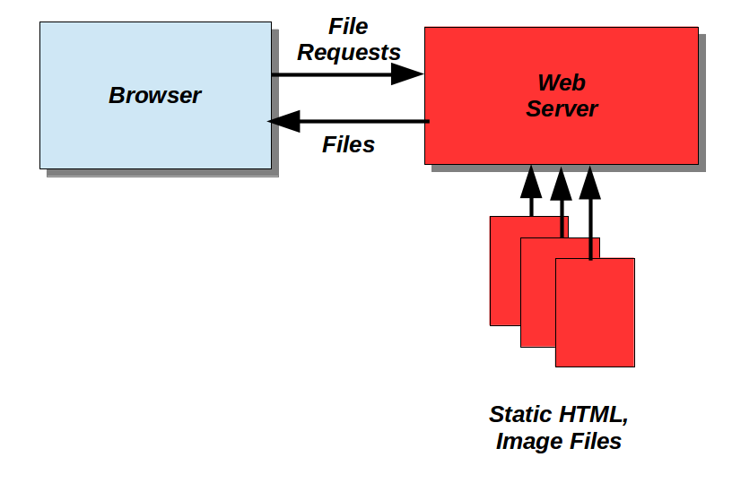

The software running on your local computer appears in blue, while that on the remote Website is in red. The browser requests files (over the Internet) from the Website, which retrieves them from its storage and returns them (also over the Internet). All these files are static; that is, they don't change during the conversation. Of course, the Website manager changes them in order to keep the site current.

The conversation begins with the browser requesting the site's home page. The file is not an image of the page, but a program in HyperText Markup Language (HTML) that the browser uses to construct what you see. A simple example appears below. This shows a display from a text editor with some enhancements to ease HTML coding. In particular, HTML commands appear in purple.

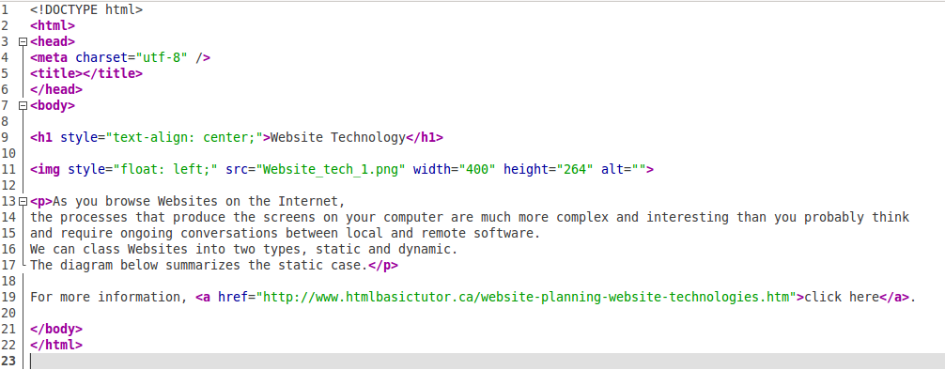
Line 1 tells the browser that this is an HTML file. In HTML, every element is enclosed by tags that take the form of characters within a < > pair. For example the tag <html> on line 2 marks the start of the program and </html> on line 22 marks its end. Within this is another section, enclosed by <head> on line 3 and </head> on line 6 that (in this example) tells the browser how characters are encoded. (Most sites have larger head sections.) The <body> and </body> tags on lines 7 and 21 enclose the code that actually defines the page to be displayed.

This page begins with a level-1 header. In a simple case the tags would be just <h1> and </h1>, but the starting one includes style=”text-align: center;” to cause the header to be centered on the page. The code on line 11 tells the browser that it should request the file website_tech_1.png and display it as a 400- by 264-pixel png image. However, as with the header, the beginning tag <img> includes style=”float: left;” to cause the image to appear to the left of the following paragraph, which is enclosed by the <p> </p> tag pair.

This code produces the result below.

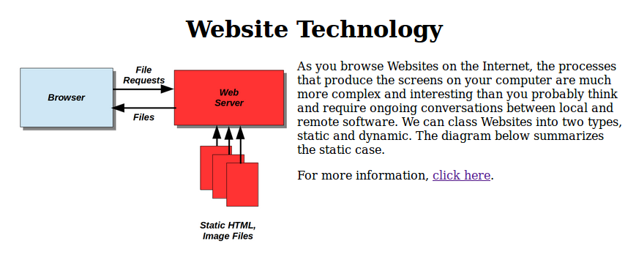

The last line of text results from the code on line 19, where clicking on the underscored purple text “click here” will cause the browser to request a file from the site specified in quotes. In the user's view, this is a transfer to a new Website.

As you can see, a lot goes on to display even a simple static page, and most sites contain many pages, most of which are far more complex than this example, although the basic processes are simple.

In the early days of the Internet, all Websites were static, and many still are. However, many businesses and organizations need such features as log-ons, bulletin boards, and the ability to accept user inputs, which a static site can't provide. To accommodate them, dynamic Websites, as shown below, have been developed.

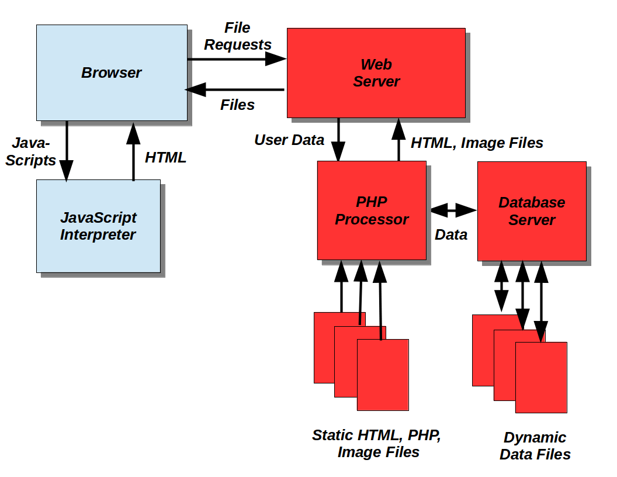

These have the same elements as static sites, but add a JavaScript interpreter on the user's computer and a PHP processor and database server at the Website provider. (Many dynamic Websites use a different set of software.) Transactions begin as above with the browser requesting a file from a Web server, but here the server has a PHP processor that generates HTML pages from the PHP files and sends these to the browser. This allows each page to be customized according to input from the user. The database server keeps track of any data related to the session and makes this available to the PHP server. Because many people may be using the site, it can be difficult to keep track of which data belongs to each user, and database servers do this automatically. As a result, the HTML, PHP, and image files can be static; anything that varies or is associated with a particular user is handled by the database server.

Some operations must run on the user's computer, and these are often defined by JavaScripts embedded in the returned HTML pages. If so, the browser sends these to a local interpreter before displaying the page. The Web server is often Apache and the database server is often MySQL. On a Linux host the combination is called a LAMP (Linux, Apache, MySQL, PHP); on a Windows host this becomes a WAMP, and on a Mac a MAMP.

To illustrate the operation of a dynamic Web page, we'll add a small PHP function and a small JavaScript to the HTML code we examined above.

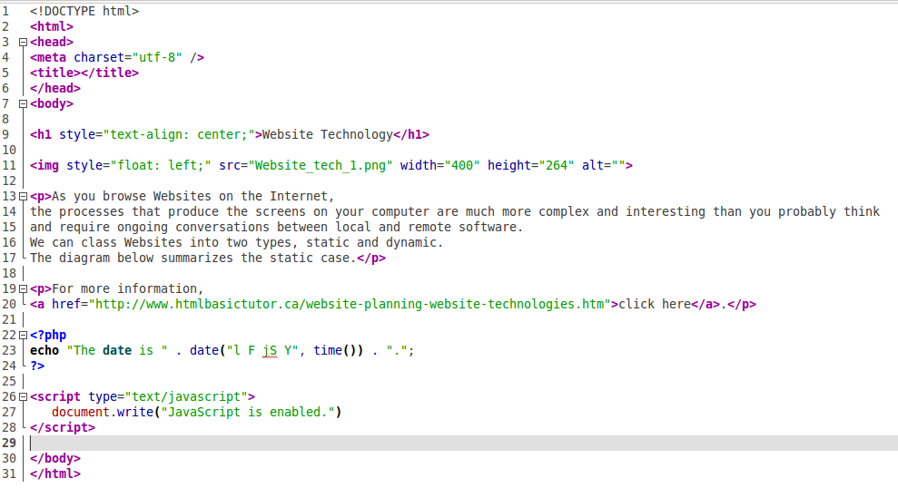

The PHP code appears between the tags <?php and ?>. It includes the function time() to find the time on the server (expressed as the number of seconds since the start of January 1, 1970), the function date() to format this into a readable form, and the function echo to create an ASCII string; the details aren't important here. The PHP interpreter will replace this code with the ASCII string before it sends the file to the PC's browser. Similarly, the JavaScript code appears between the tags <script type="text/javascript"> and </script>. If the browser has a JavaScript interpreter, it will print the enclosed text; if not, it will ignore everything between the two tags. The screen-shot below shows what the server returns to the browser; the PHP code has indeed been replaced by an ASCII string, and the JavaScript and HTML is just passed down unaltered, except for some minor reformatting.

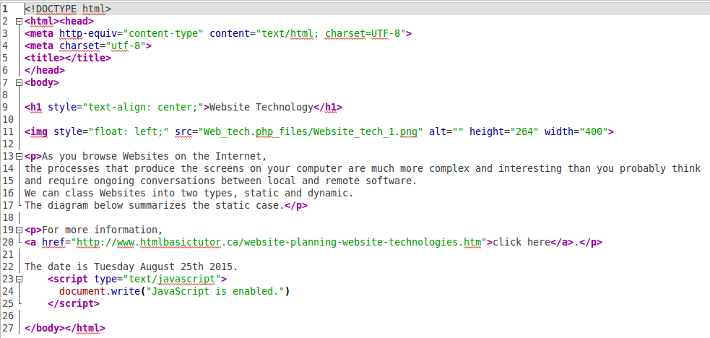

The screen-shot below shows the browser's display of this code. The text, “The date is Tuesday August 25th 2015” was inserted at the Website and, “JavaScript is enabled,” by the interpreter at the user's browser.

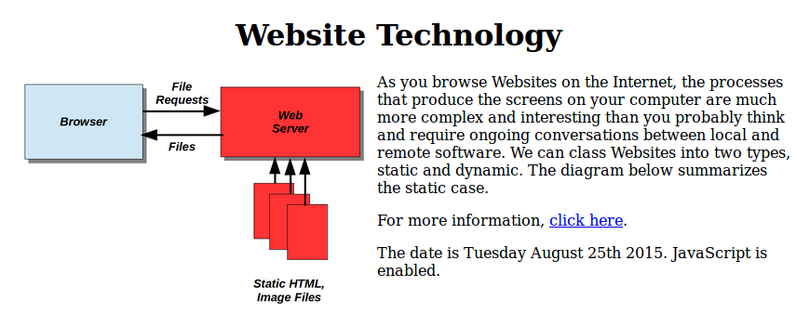

Of course, real PHP and JavaScript code is far more complex than these simple examples, and typically both produce far more useful results, but they are inserted into HTML code just as you've seen here.

HTML allows users to set their browsers to provide comfortable viewing, for example by adjusting the font and window sizes, and the formatting is adjusted to accommodate this, primarily by adjusting the lengths of text lines. Adding PHP code allows the Website to provide interactive features for its users while letting them use standard browsers. JavaScript does require a browser enhancement, and some users disable this feature because they are reluctant to allow sites to run programs on their home computers. As a result JavaScript often provides decorative rather than essential features.

Of course, JavaScript is not the only program that can run on your PC, and PHP is not the only one that runs on a server, but these are probably the most common. In other words, the general architecture shown here is typical, although the names of the programs may vary.

